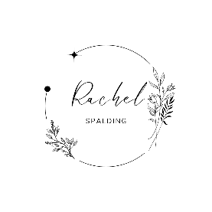
Table of testimonials
Form for others to submit testimonials
Image
H1 – Rachel Spalding
Font: Ballet or Imperial Script

Nav menu (list): Full about me with work history; education; projects – including WWR & ICE
H3 – Headline
Background: #a5aec9 – (still deciding-will need to see it all typed out & such)
Text color: #0a173b or #0f1c52
Font: Open Sans

H6 – About
Paragraph – About me info
Background: #eaf0f7
Text color: #0a173b
Font: Open Sans
Navigation Menu
Footer (contact info – social media & linkedin links)
Text color: #0a173b
Font: Open Sans

